1926 Team / Committee Photo

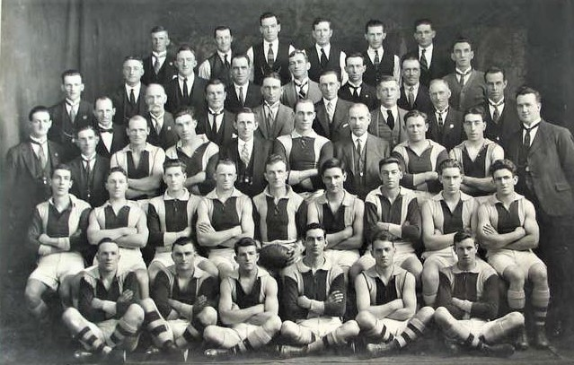
Back row: Artie Dillon, Arthur Ludlow, Ernie Hannah (Secretary), Arthur Stevens, Henry Zwar (President), Jack Sherman, Unknown
Middle row: Frank Ludlow, Unknown, George Robertson, Unknown, Gus Dobrigh, Surtees, Percy Ellis, Unknown, Stanley Joseph Marmo
Front row: David Hume, Danny Warr, William Summers, Walter White, Unknown, Jack Watt

1926 (game day) Team Photo
I believe this photo is of the Round 1 team, found here – http://www.thevfaproject.org/pages/Games/VFA1926-R01-05.php
There are 21 in it, and my understanding is that back then 18 were named each week, along with 3 emergencies. Later (1930s?) it became 18 plus a 19th man.
My only concern on this belief is that I cannot identify Arthur Stevens in this photo.

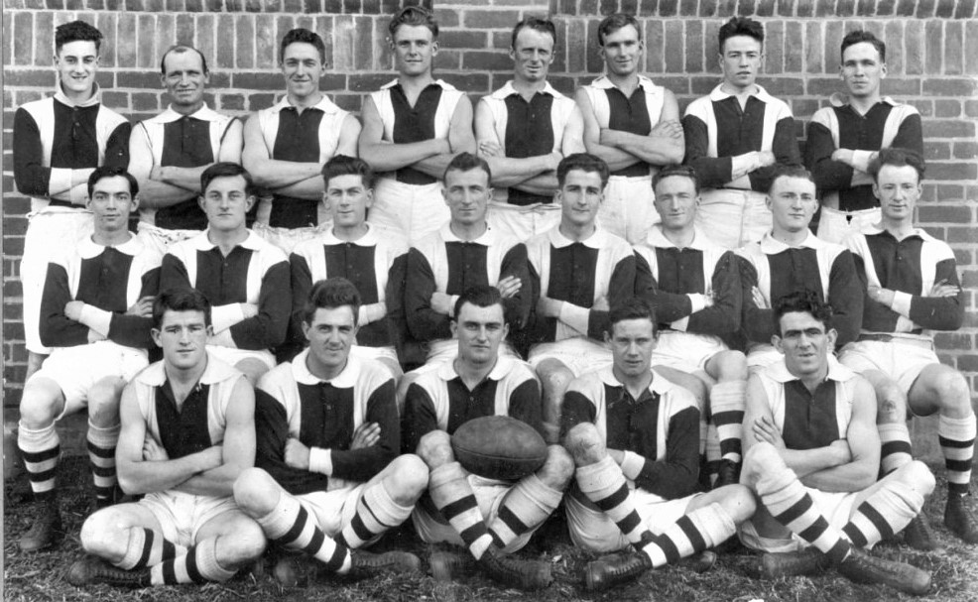
Back row: Unknown, Artie Dillon, Unknown, Lyle Seebeck, Unknown, Dave Holliday, Unknown, Unknown
Middle row: Walter White, Unknown, George Robertson, Gus Dobrigh (Capt), George Surtees (VC), Herbie Taylor, Unknown, Unknown
Front row: William Summers, Poss George Skipper, Danny Warr, Jack Watt, Stanley Joseph Marmo

1923 Team / Committee Photo

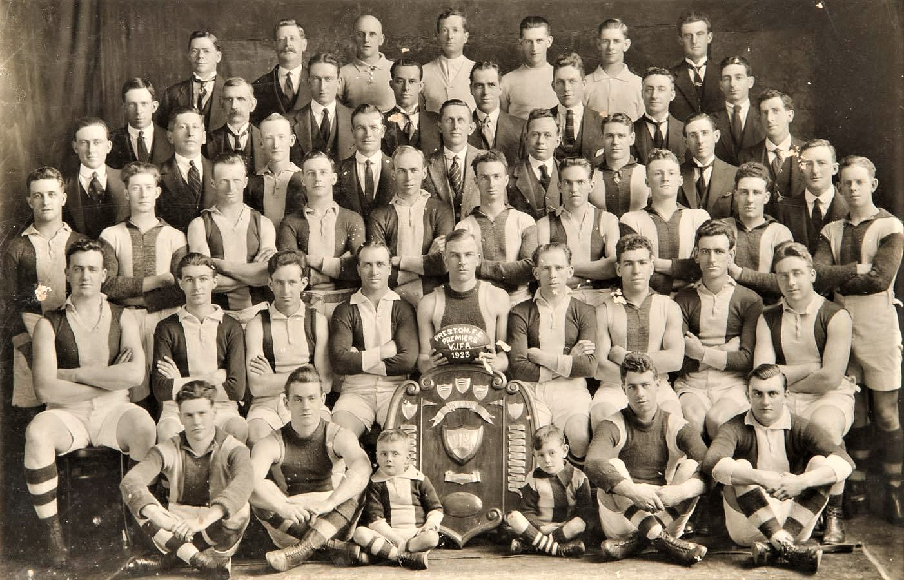
Back row: Unknown, Unknown
Third row: Unknown, Unknown, Unknown, Unknown, Unknown, Unknown, Unknown, Unknown, Unknown, Unknown
Second row: Unknown, Unknown, Unknown, Percy Ogden, William ‘Bull’ Adams, Les Punch, Unknown, Unknown, Unknown,
Front row: Unknown, Unknown, Unknown, Danny Warr

A far more difficult photo to identify, mainly due to the fact that this was when Preston was playing in the VJFA. They didn’t re-enter the VFA until 1926.
Names of players found listed in various 1923 newspapers, along with the Bullants history book, with the names in red being players that are / could be in later photos –
Percy Ogden, Routledge*?, Sheehan, Stevens (prob Arthur), Laurie, Muir, Griffiths, Ward, Underhill, Ern Michel, Hugh ‘Red’ Moffatt, Routley*?, William Adams, White (prob Walter), Mahoney, Norman ‘Ding Dong’ Long, G. Thorp, Hamilton, Walker (poss George, or P.), Greenhaugh, Les Punch, Deacon (prob Jack – Bert’s father), Power, Danny Warr, Sutherland
I have identified Stevens, White and Warr, in other photos, but only Warr in this one.

